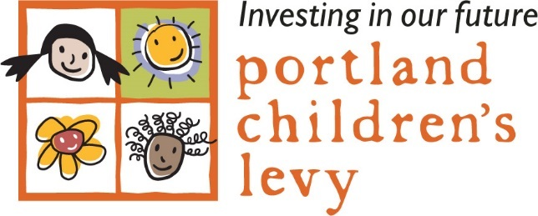

AGENDA
Allocation Committee Meeting
Monday, October 22, 2018
3:00 – 5:00 p.m.
City Council Chambers, 2nd Floor, City Hall
1221 SW 4th Ave., Portland, OR

Agenda Item Presenter Action

Welcome/Introduction Dan Saltzman Information
Welcome New AC Member Felicia Tripp

Approve Minutes Dan Saltzman Vote

Public Comment Public Information
Non-agenda items

Grantee Program Video John Coghlan Information

Funding Process Outline Staff Info/Discuss
- 2 year Process (July 2018 – June 2020)
- Renewal of existing grants for additional year considered Spring 2019
- Community engagement process (September 2018 – April 2019)
- Grantmaking process review (September 2018 – January 2019)
- Local Data Report: Portland’s Children

Grantmaking Process Review Project Update Staff Info/Discuss

Community Engagement Draft Plan Kheoshi Owens Info/Discuss/Vote

Adjourn

